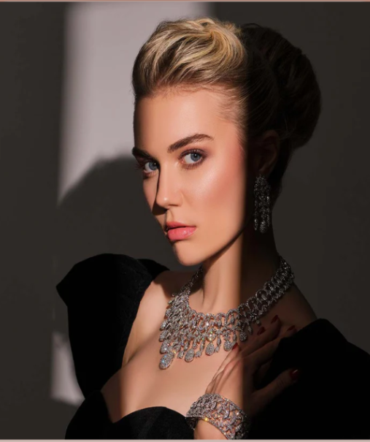

**Developers Guide**

**E-PROJECT**

**PASCAL IMITATION**

**PASCAL IMITATION**

*Developer Guide*

|  |  |  |
| --- | --- | --- |
| **Supervisor.** | **Miss Quratulain Haider** | |
| **Batch.** | **2406e1** | |
| **Group.** | A | |
| **Serial No.** | **Enrollment Number** | **Student Name** |
| 1. | 1579415 | Alina Habib |
| 2. | 1580761 | Bisma Kamran |
| 3. | 1580762 | Zayyan Kamran |
| 4. | 1581074 | Firza Navaid |

**Home**

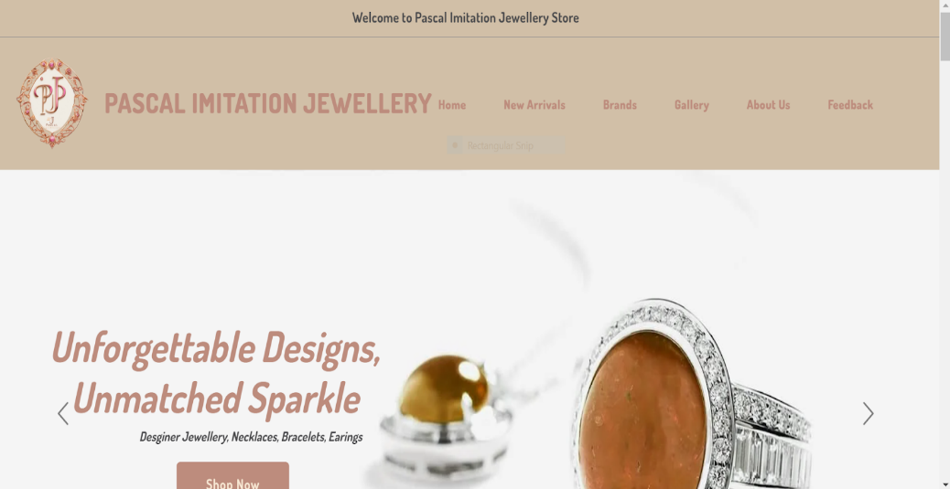

**Code of Home page**

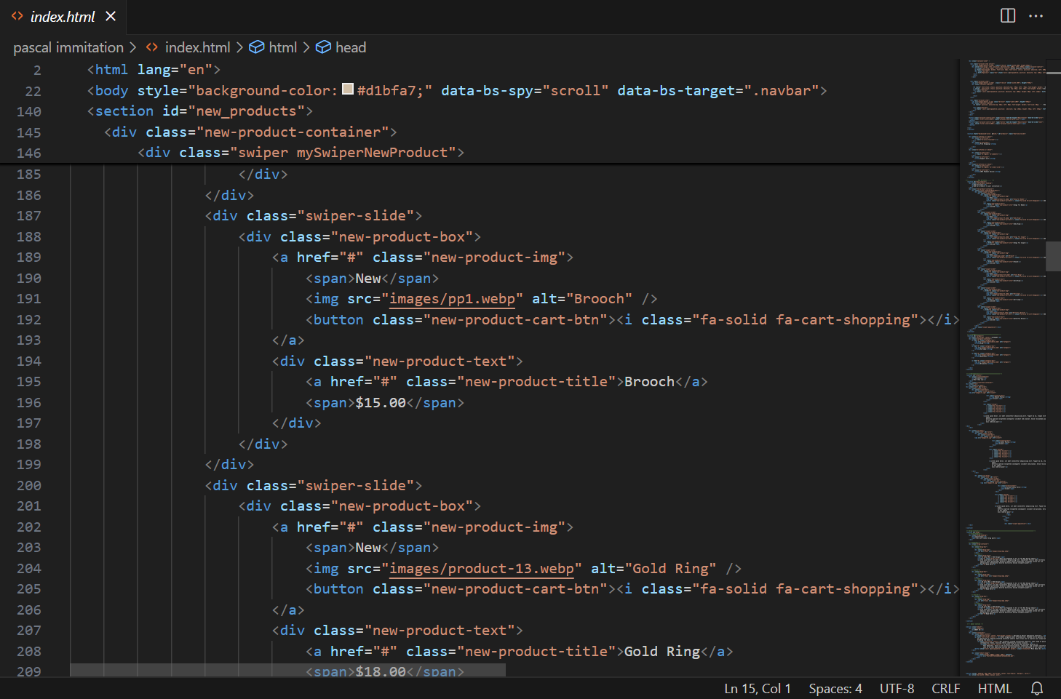

***Figure 1 and 2: Home page***

**Navbar**



We have given seven essentials. By clicking any of the essential’s and redirect to the linked page.

**Code of Navbar**

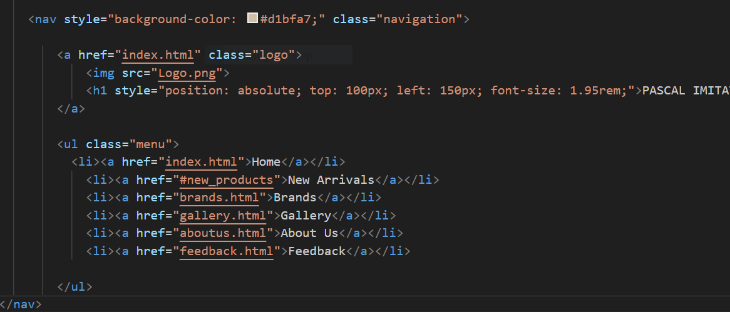

***Figure 3 and4: Navbar***

**About us**

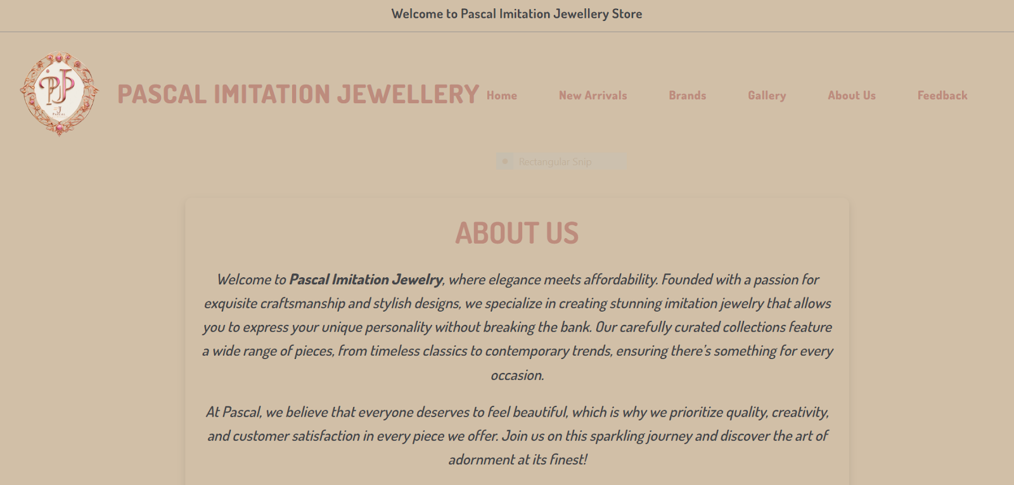https://lh7-rt.googleusercontent.com/docsz/AD_4nXcAEQSiq0LeJFxly5NuQ9T6OauUMgl3L0pN_b628N2ZHG2_60kdZvvVYL3hGz8lGoyGv8yeUOhulBV5DdFZUu0xMCNqZBOLkvcQYbhlxIPI7WGXleJwcNZo9y4L0JuhZwLCsIIturopra_HlrAHxIJ4JxrZCI_BFufn7p5D?key=ibviCqHSxlD2qIdH8sVwnUh9https://lh7-rt.googleusercontent.com/docsz/AD_4nXdc44zf89Sqt7ICsJPDXv1O8TA00drpIdXlarGWQB824RLX77RPiRa8AsLhiWc-AO-gjCaLt0O1GU1f8kDCUmdIYJZMJVaXaVlQp6ghLpJK7-P8PhAzR2O-88CrmBAUKayptYStmRqoLC2KDBhcwCm3O9kxgDBi8tb2ayKEIQ?key=ibviCqHSxlD2qIdH8sVwnUh9

* ***Code of About Us***

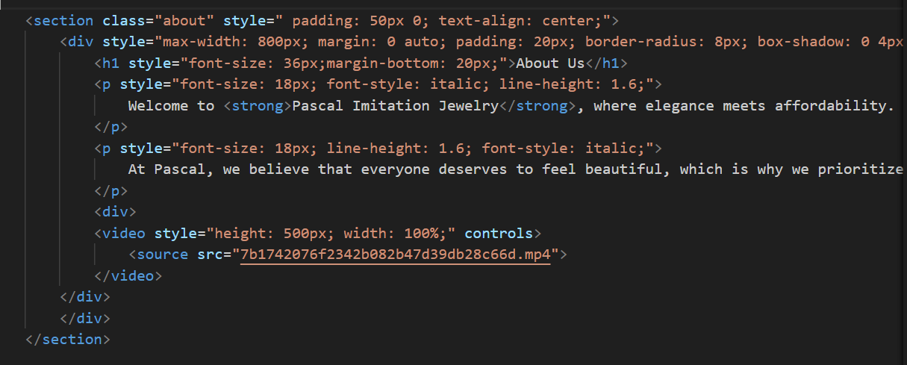

* ***Figure 5 and6:About us***

**Brands**

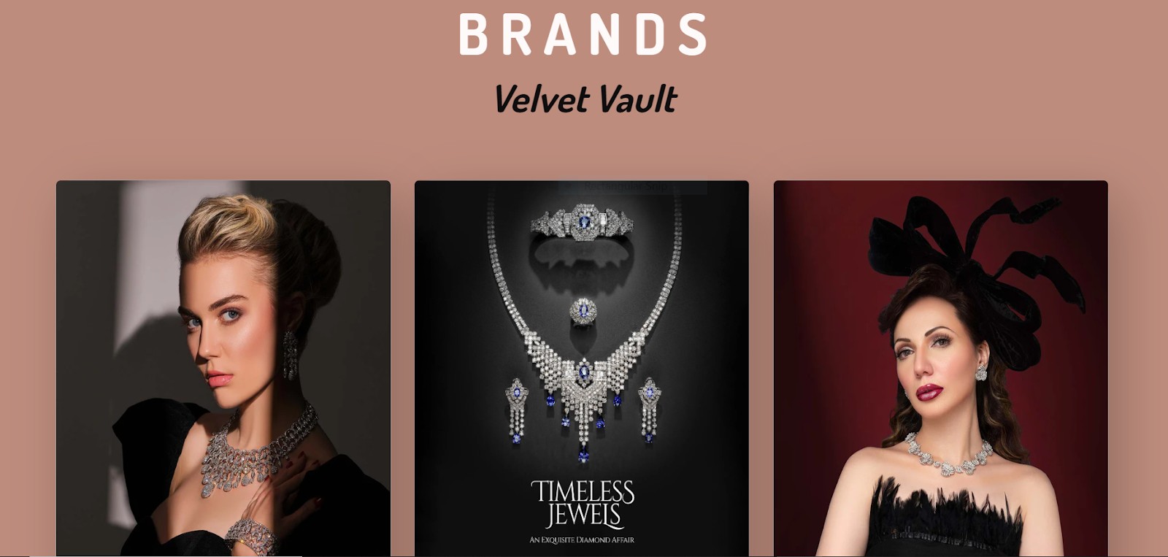

***Code of Brands***

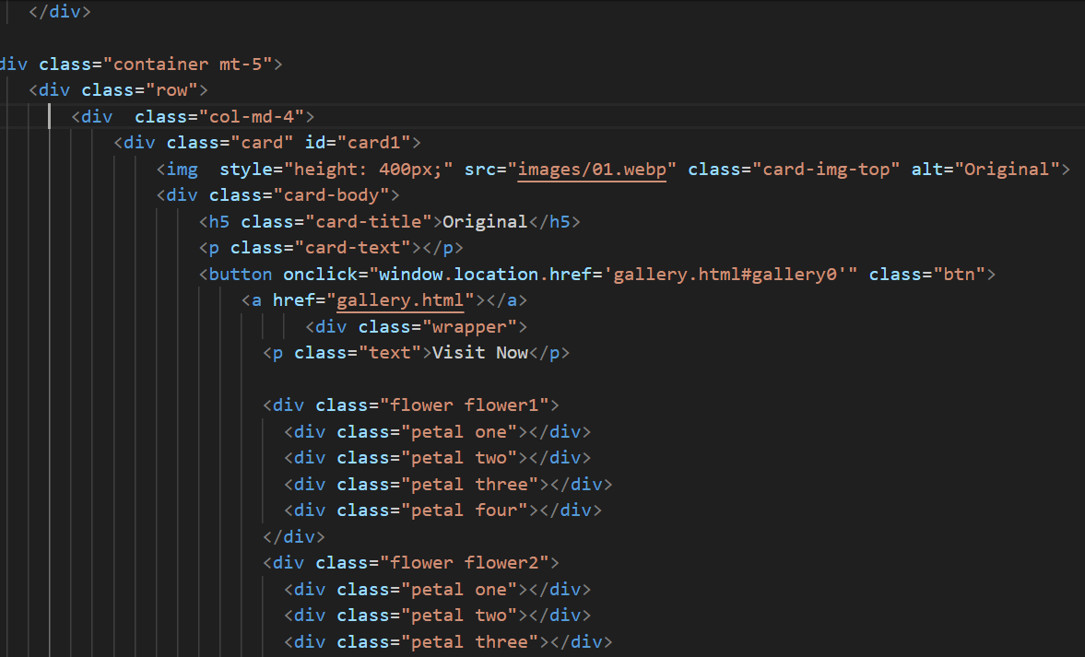

***Figure 7and8: Brands***

***BRANDS DISCUSSED IN DETAIL***

***VELVET VAULT***

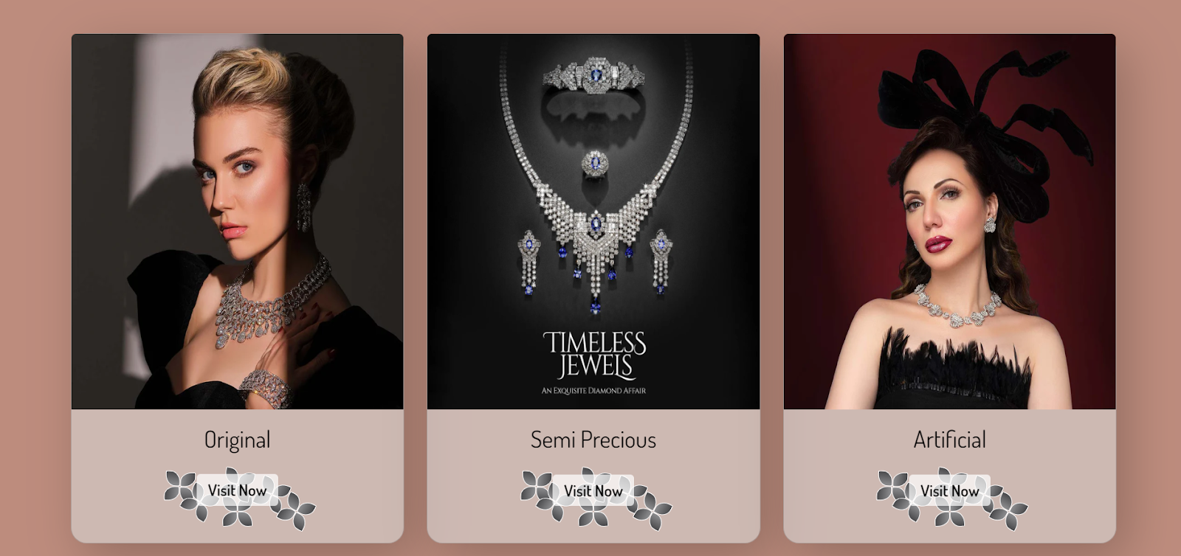

https://lh7-rt.googleusercontent.com/docsz/AD_4nXdzl3WjktvtRgiSZbNVLaaVI1m4z57o13dvRY-iJn8yf8vE5kviZxaHTbY1mib5DHoTcTWdrEHogvUz2iCQ8TQghyfP36pNLb4g_ejIprvSOP30ZlJDSw2HrTReYdojIzq5Fyc9tcYrtKXNmNatAEegz869SePjWnvkUQUVTA?key=ibviCqHSxlD2qIdH8sVwnUh9

***Code of VELVET VAULT***

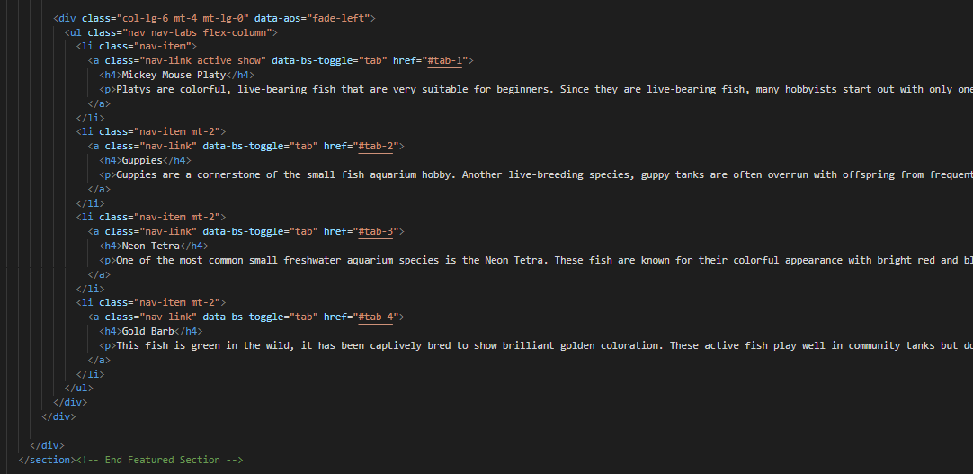

***Figure 9and10: velvet vault***

***velvet sparkle:***

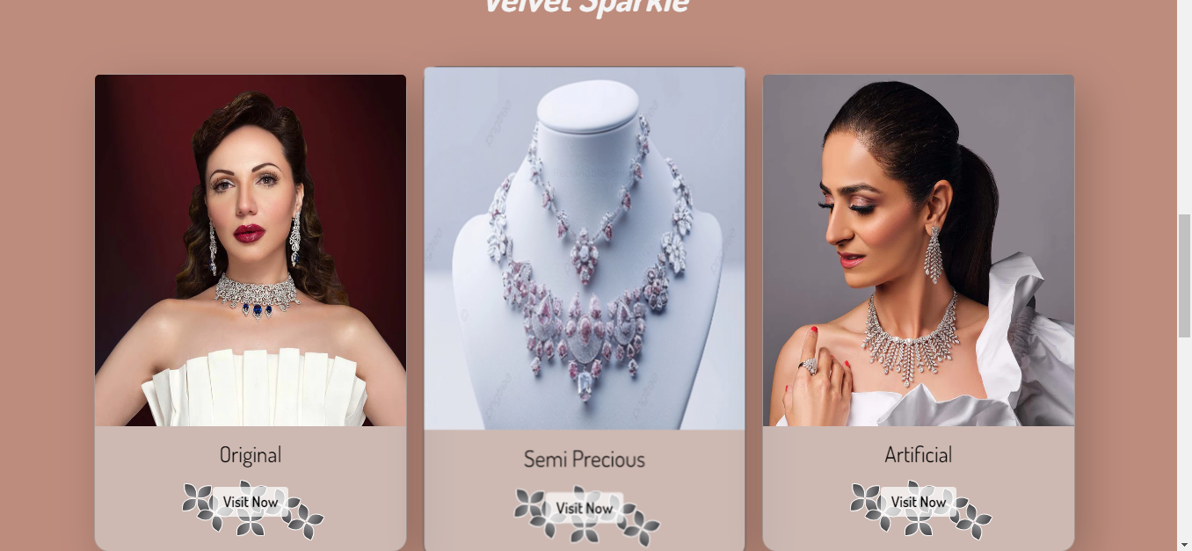

***CODE OF VELVET SPARKLE***

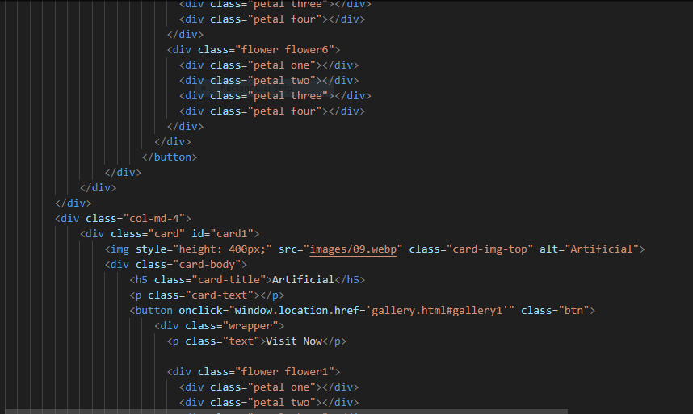

***Figure11and 12: velvet sparkle***

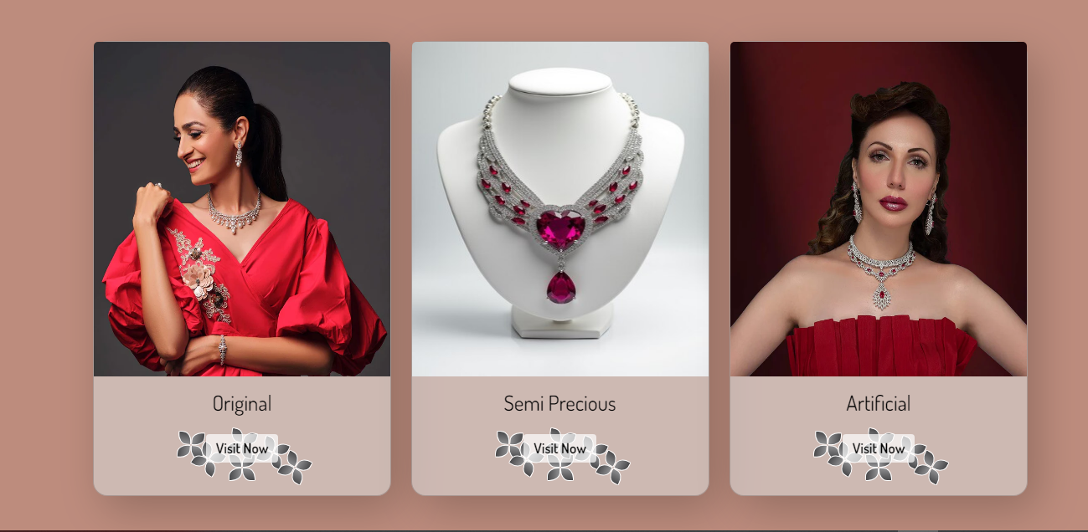***VELVET ELEGANCE***

***CODE OF VELVET ELEGANCE***

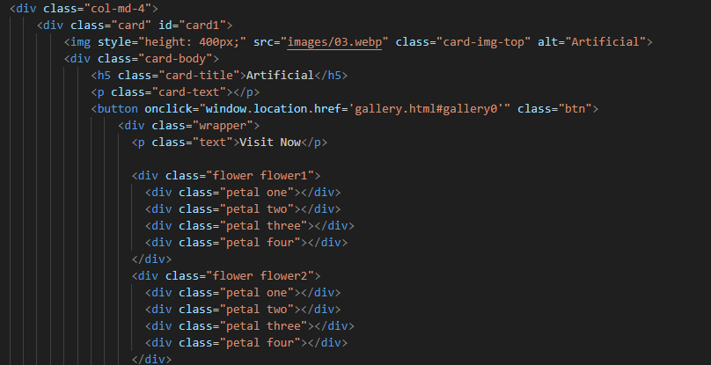

***Figure13and 14: velvet elegance***

***Our jewellery video:***

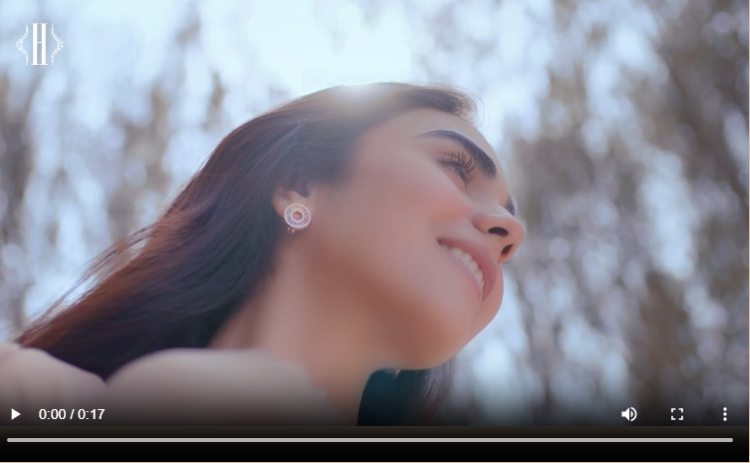

***Code of Linked Video***

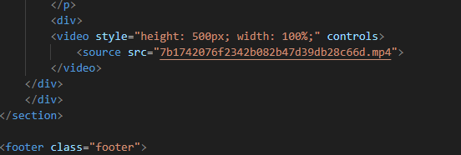

***Figure15and 16:Coding Linked Video***

***feedback:***

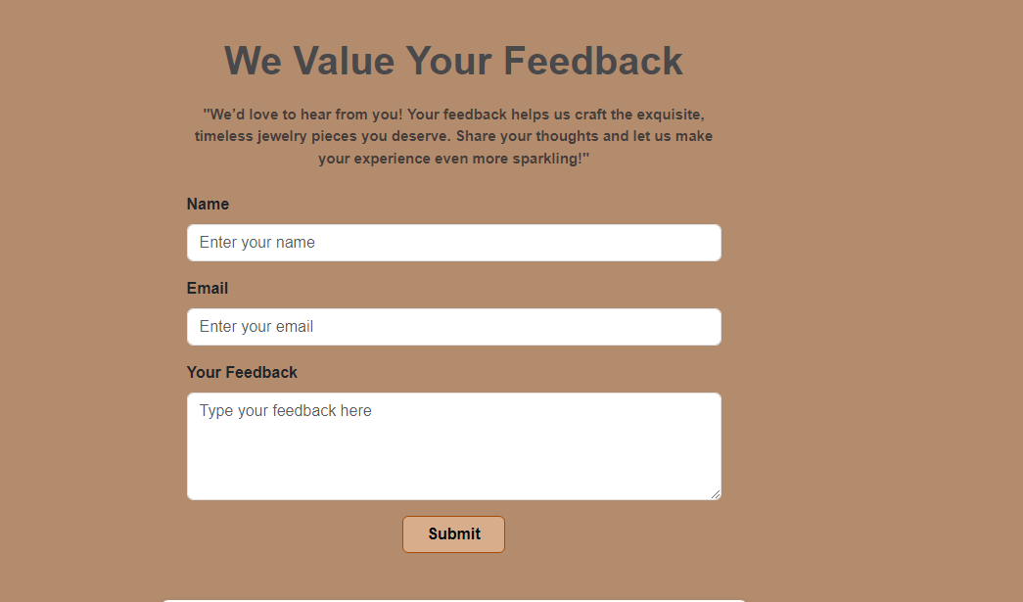

***Code of Feedback***

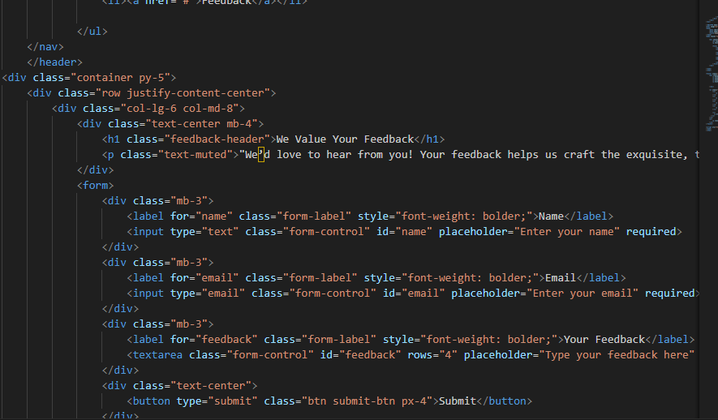

***Figure 17and18: feedback***

***contact us***

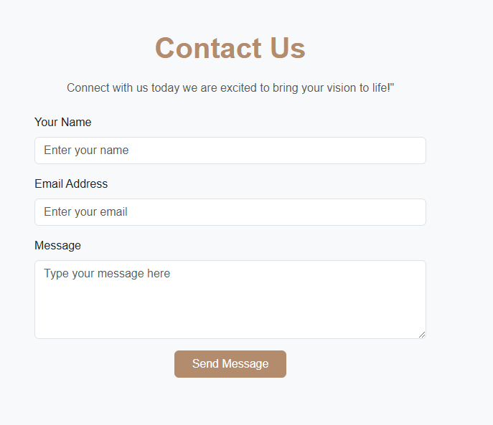

***Code of contact us***

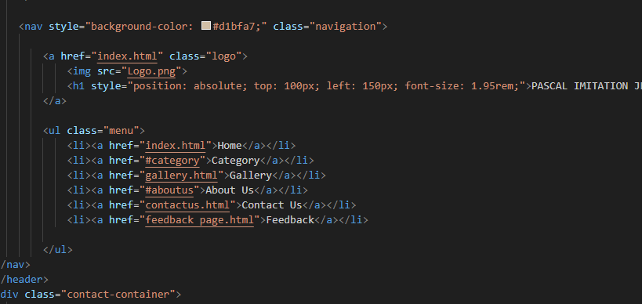

***Figure 19and 20: Contact us***

***categories:***

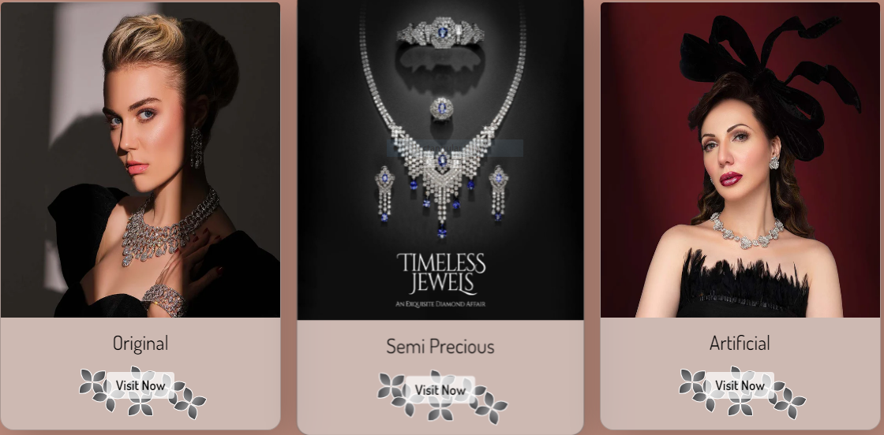

.

***Code of categories***

***Figure 21and22: categories***

***CATEGORIES  DISCUSSED IN DETAIL***

***ARTIFICIAL:***

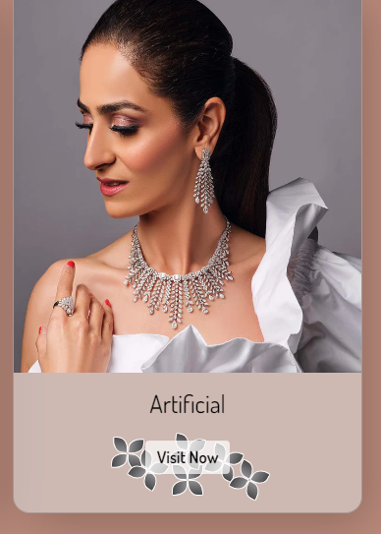

***Code of Artificial***

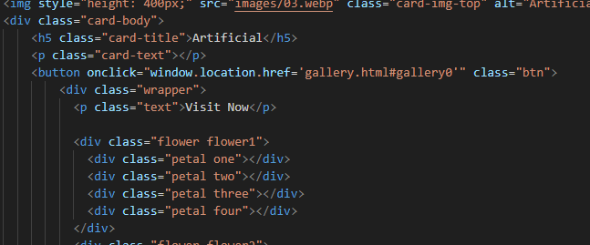

1. ***Semi Precious:***

***Figure 23and24: Artificial***

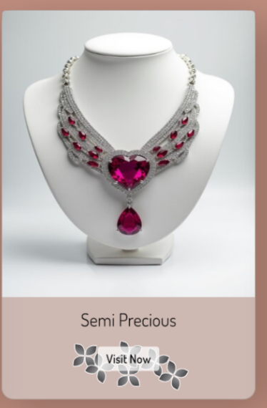***SEMI PRECIOUS:***

***Code of Semi precious***

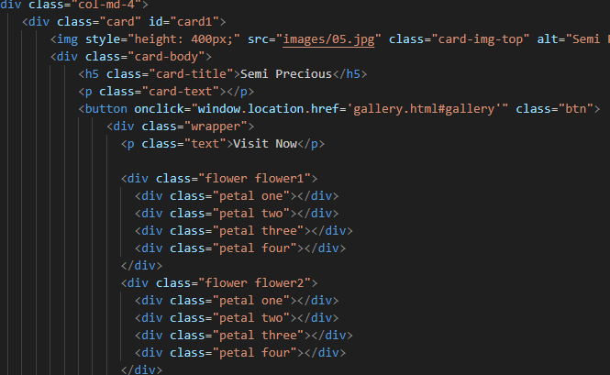

***Figure 25and26: Semi precious***

***Original:***

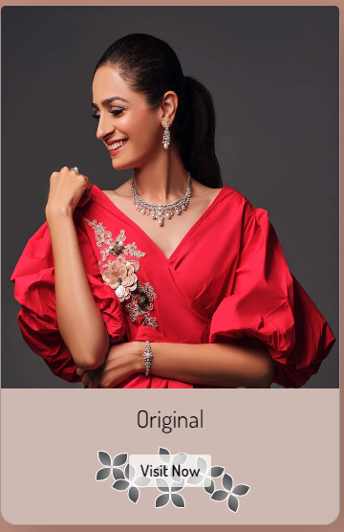

***Code of Original***

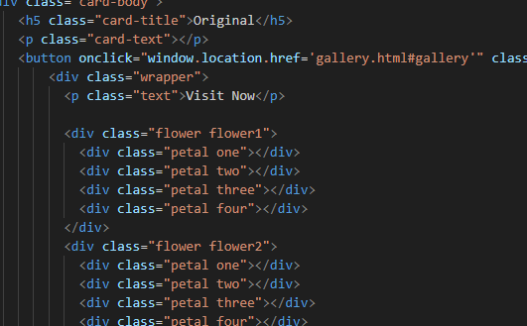

***Figure 27and28:Original***

***Footer:***

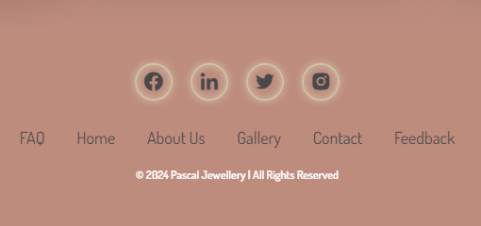https://lh7-rt.googleusercontent.com/docsz/AD_4nXeyGIMMmyEWXzs0kzSI47vf3yMN12F5DbwA2c49LJVkoF7N-FYeJkyzAKXqe3o63BfchShaUYOy-SUM6sNh1jF4GBxB4S6_4xi94wHHUNJeX-SKcRewmr2AB75KN5y3VL4rvDdI6fQm1uKQLDBg3KXDRUn04HuexVPV6WRS?key=ibviCqHSxlD2qIdH8sVwnUh9

***Code of Footer***

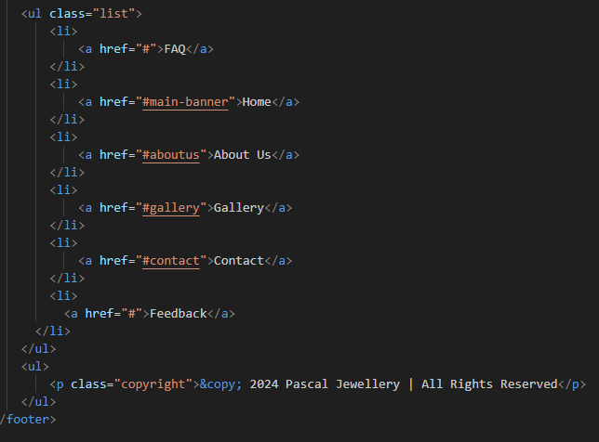

***Figure 29and30: Footer***